**Module-2: GIT Assignment - 3**

You have been asked to:

● Create a git working directory, with the following branches

○ Develop

○ F1

○ f2

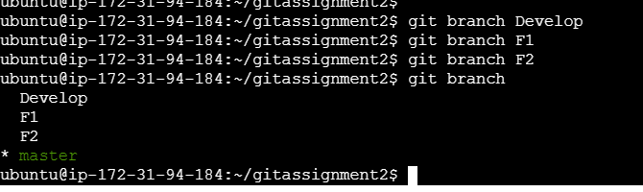

● In the master branch, commit main.txt file

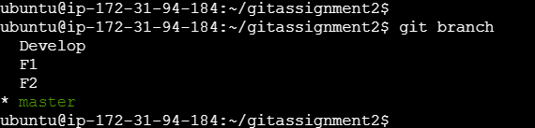

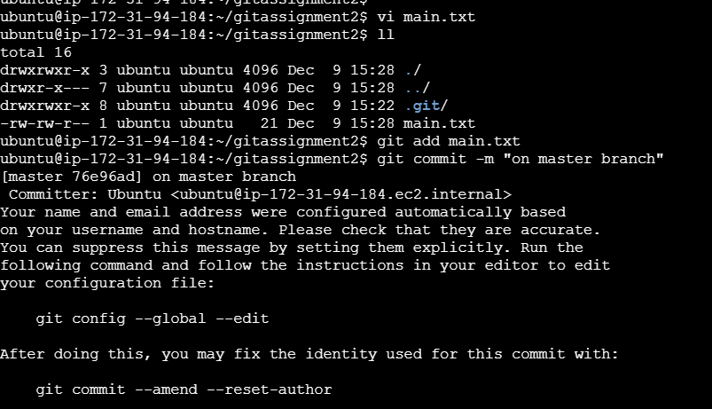

● Put develop.txt in develop branch, f1.txt and f2.txt in f1 and f2 respectively

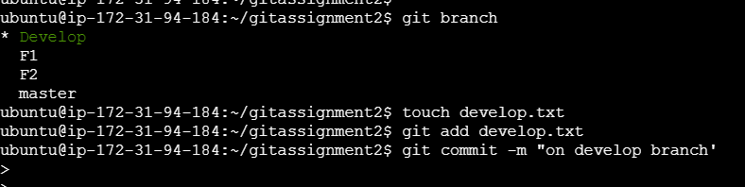

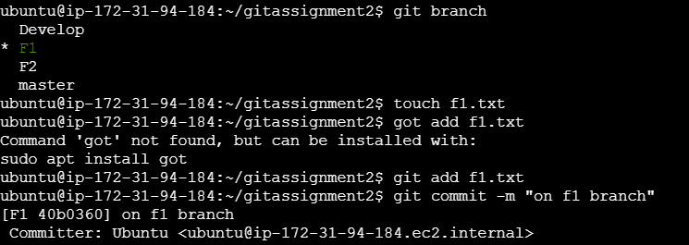

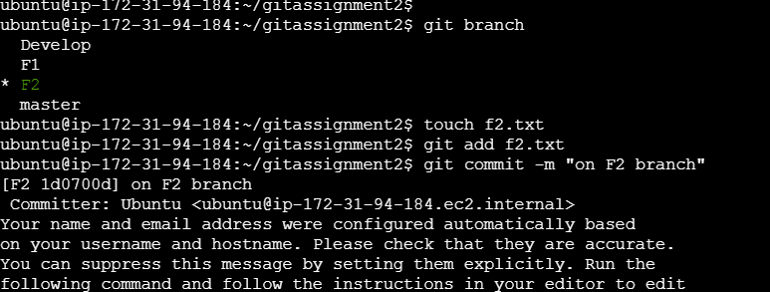

● Push all these branches to github

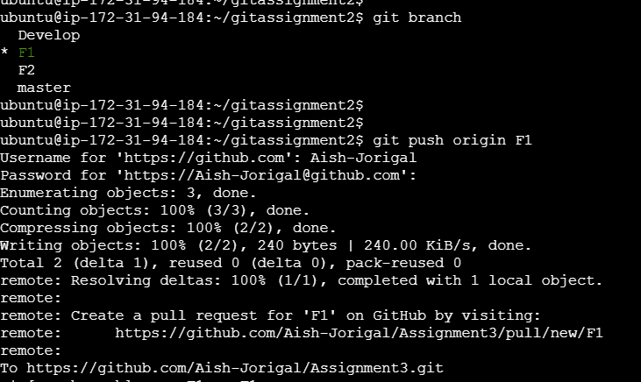

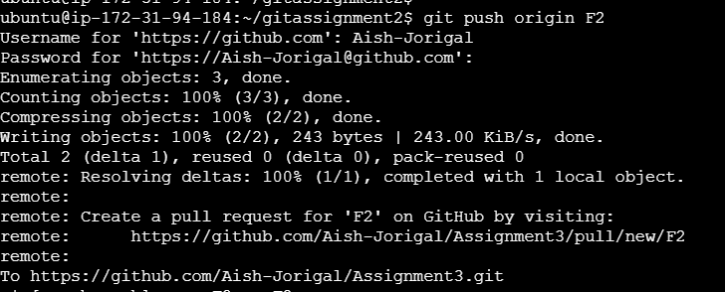

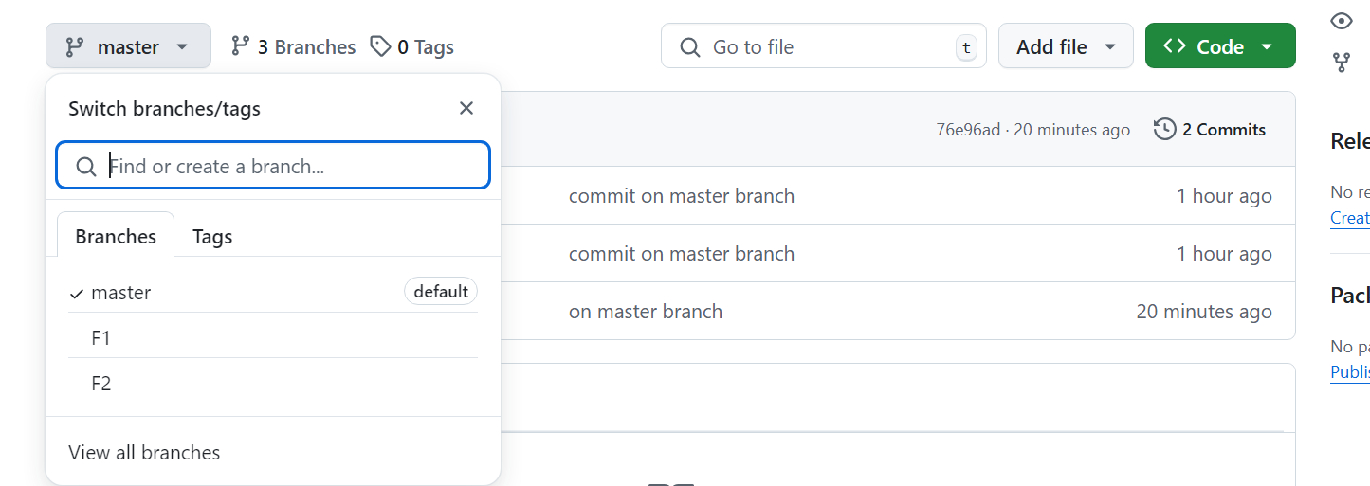

● On local delete f2 branch

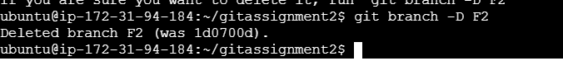

● Delete the same branch on github as well

